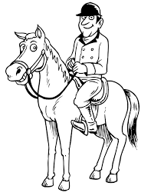
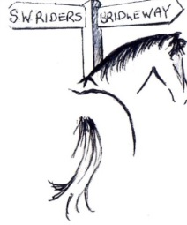
SOUTH WEST RIDERS

MEMBERSHIP FORM

Individual - £5.
Family - £7.

Please fill in all names in name section & as many details as possible. Thank you.

Name…………………………… Name………………………………

Name…………………………… Name………………………………

Contact Number(s) ……………………………………………………

Email………………………………………………………………………

Address……………………………………………………………………

………………………………………………………………………………

………………………………………………………………………………

Total amount due ………………

How did you hear about South West Riders?

……………………………………………………………………………

Please send to Amanda Fenton, Forest Lodge, Lydford, Okehampton, EX20 4BP – 01822 820068

Cheques made payable to South West Riders.

www.southwestriders.org.uk

We are Affiliated to the British Horse Society & established in 2001.

Membership runs April to April.

Please use the back of the form to highlight any issues concerning Rights of Way affecting you.
SOUTH WEST RIDERS

MEMBERSHIP FORM

Individual - £5.
Family - £7.

Please fill in all names in name section & as many details as possible. Thank you.

Name…………………………… Name………………………………

Name…………………………… Name………………………………

Contact Number(s) ……………………………………………………

Email………………………………………………………………………

Address……………………………………………………………………

………………………………………………………………………………

………………………………………………………………………………

Total amount due ………………

How did you hear about South West Riders?

……………………………………………………………………………

Please send to Amanda Fenton, Forest Lodge, Lydford, Okehampton, EX20 4BP – 01822 82006

Cheques made payable to South West Riders.

www.southwestriders.org.uk

We are Affiliated to the British Horse Society & established in 2001.

Membership runs April to April.

Please use the back of the form to highlight any issues concerning Rights of Way affecting you.
Our Mission Statement:

- To work closely and co-operate fully with all statutory and other bodies to explore all access opportunities, influencing policy making wherever possible.

- Encourage creative thinking in the planning of safe Off-Road Equestrian Routes.

- To press for the creation of new Bridleways and the improvement of those in existence.

- To link existing Bridleways and other equestrian routes to create an effective network.

- To work with statutory authorities to improve road safety.

- Recognise the legitimate needs and concerns of landowners/managers affected and work towards ensuring any routes are satisfactory to them.

- Press for the development of Multi-use trails and actively support Horse Riders on existing cycleways.

8. Actively pursue research of ‘lost ways’ bringing awareness of the 2026 cut off point for claiming old routes to the fore front.
_________________________________________________________________________

Our Mission Statement:

- To work closely and co-operate fully with all statutory and other bodies to explore all access opportunities, influencing policy making wherever possible.

- Encourage creative thinking in the planning of safe Off-Road Equestrian Routes.

- To press for the creation of new Bridleways and the improvement of those in existence.

- To link existing Bridleways and other equestrian routes to create an effective network.

- To work with statutory authorities to improve road safety.

- Recognise the legitimate needs and concerns of landowners/managers affected and work towards ensuring any routes are satisfactory to them.

- Press for the development of Multi-use trails and actively support Horse Riders on existing cycleways.

8. Actively pursue research of ‘lost ways’ bringing awareness of the 2026 cut off point for claiming old routes to the fore front.
_________________________________________________________________________

